Problem-1: Write a Java program that demonstrates the Exception Handling in Java

Code:

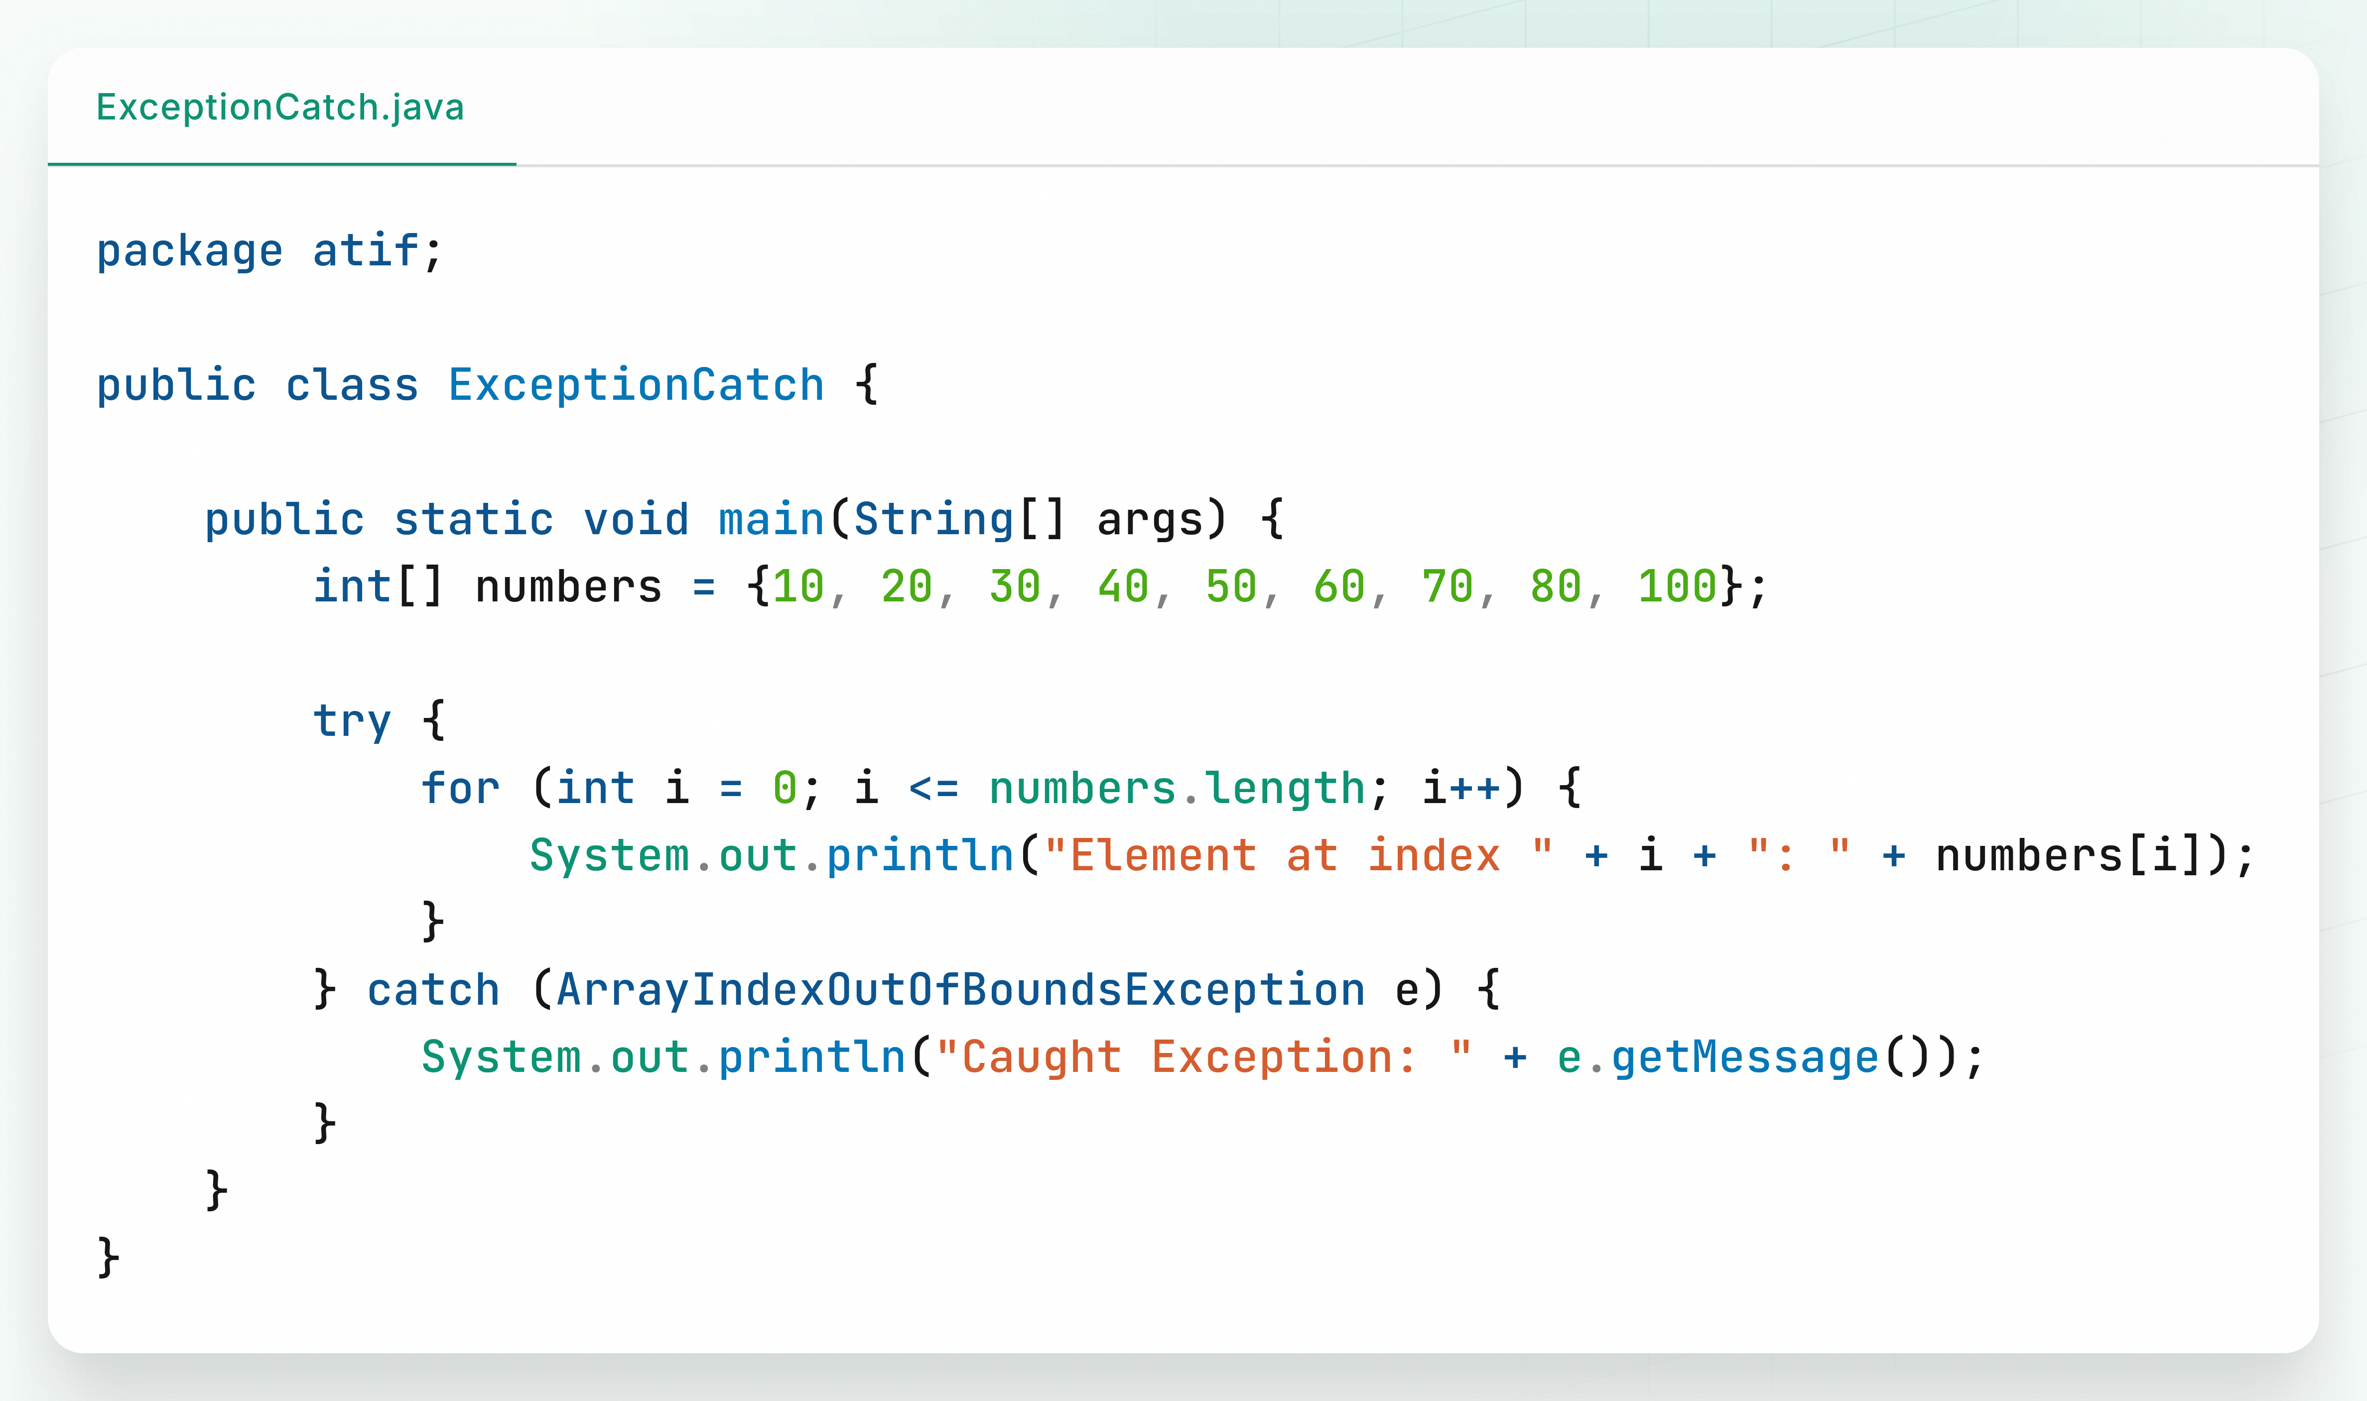

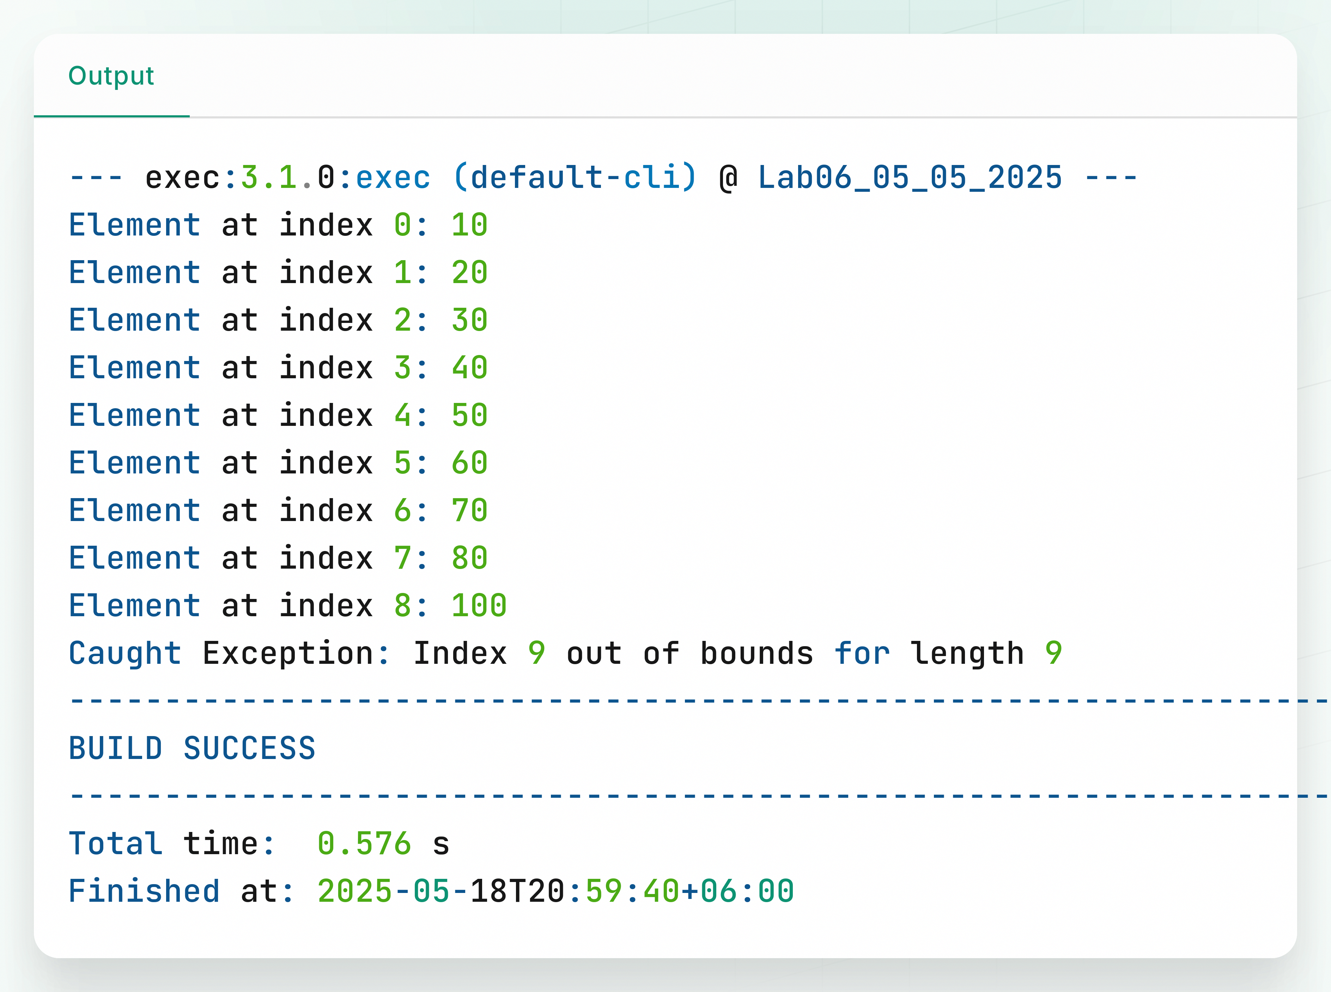Output: